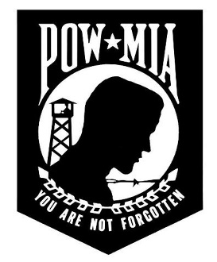
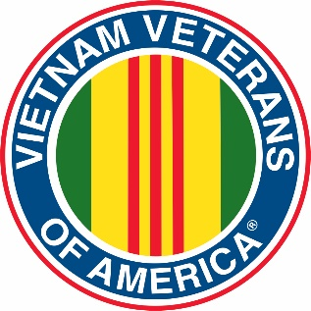
Vietnam Veterans of America
Chapter 331

The April 08, 2023 meeting was held at the GasLite – the meeting was called to order at 1:10pm by President Jim Ottman with the Pledge of Allegiance and a moment of silence for our fallen and serving service members, POW/MIAs and for John Telschow who is currently undergoing treatment for Cancer.

Treasurer was not in attendance

OLD BUSINESS:
- The Highground is looking at alternatives to the new Museum they had hoped to build as the constructions costs have doubled since inception.

NEW BUSINESS:
- Scholarship Committee reports that they received 8 scholarship applications this year. The committee will be meeting in April to choose our two recipients.

- The Pierce Pepin Cooperative Services held “Fur, Feathers and Fidelity – Military Mascots” celebrating the role animals have played as a source of pride and morale for troops since the Civil War. The display was held March 31 – April 13

- Richard Cady gave an update on the Woodbury VFW Memorial Day 2023 Event. They are looking for Veterans for the Rifle Squad and to participate in moving a memorial casket. The Static Helicopter Display will be there. For more information on the Memorial Day event go to: https://www.facebook.com/woodburypost9024/

To contact Richard in regards to the Rifle Squad or being a Casket Bearer:
richardcady@usfamily.net

- Jim gave an update on the State Council Meeting held in Waupaca in March. They are still giving out scholarships and they had a Presenter speak to them regarding PTSD. The Council is looking for places to hold town hall meetings in regards to this issue.
For the Veterans Crisis Line Dial 988 then Press 1/Text to 838255.

- EAA in Oshkosh is honoring Vietnam Veterans this year. They flyable Chopper is going on June 23rd and may have an empty seat. If you are interested contact Jim.

- Jackets – Jim advises that they have made contact with MBC Sports in Spring Valley. It is easier for them to do them all at once or you can order at your convenience. If you would like to order a jacket, same style as we now have with baseball style collar, please let Jim know by the next meeting. MBC will also sew on any patches you would like on your new or current jacket. The break down is as follows:
  - Jacket - $71.50
  - Back Logo (Original Old Style of Lettering) - $74
  - Left Logo (Name) - $5
  - Left Arm Flag - $10
  - Left or Right inside pocket (Optional) - $6
  - TOTAL: $166.50

- Election was held for Officers - (same as last year)
  - Jim Ottman President
  - Jim Jennings 1st Vice
  - Dave Roeker 2nd Vice
  - John Telschow Treasurer
  - Dave Niederer Secretary
  - Bill Baker Chaplin

UPCOMING:
- HIGHGROUND -
  - Work weekend May 11-13
  - At the Museum:
    - Wisconsin Remembers – A face For Every Name/ a Vietnam War Memorial (courtesy of the Wisconsin Veterans Museum in Madison)
    - Two Compelling Exhibits on Display at The Highground Museum | The Highground

  - Event Calendar for 2023 | The Highground

- Memorial Day – May 29, 2023/ Helicopter Display at Woodbury VFW

- EAA – July 23 - EAA AirVenture Oshkosh | Oshkosh, Wisconsin | Fly-In & Convention

NEXT MEETING:

Our Next meeting will be held at the Hooch on May 13, 2023 at 1PM

Respectfully Submitted
David Niederer

