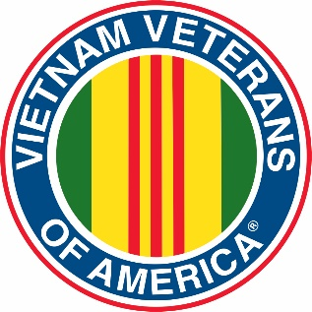
Vietnam Veterans of America
Chapter 331

November 12, 2022

The November 12, 2022 the meeting was held at the GasLite – the meeting was called to order at 1:15pm by President Jim Ottman with the Pledge of Allegiance and a moment of silence for our fallen and serving service members, POW/MIAs.

There were no minutes from October as there were not enough people in attendance for a quorum.

The Treasury report was given by Treasurer John Telschow and accepted.

OLD BUSINESS:

- New Richmond VFW reports that all the underground infrastructure for the Veterans Center have been completed and that they have secured a grant that paid the bills for the build to date.

NEW BUSINESS:

- A check was received from the Baldwin VFW for the Veterans Day Helicopter display. Associated Bank holds a “Best Veterans Day Display” contest. Unknown if they won.

- The Chapter received a Congratulations letter from National for Officially being a Chapter for 35 years.

- The Legion Magazine reported that the National Park Service is offering a Military Veteran/Gold Star FREE lifetime pass. For more information go to: https://www.nps.gov/planyourvisit/veterans-and-gold-star-families-free-access.htm

- The insurance premium for the Helicopter trailer was given to Treasurer Telschow.

- The Woodbury VFW has reserved the Helicopter for Memorial Day 2023, check to Treasurer Telschow

- VVA #331 member Diane Carlson Evans was awarded a Lifetime Achievement awardat the 2022 National Leadership & Education Conference read more about Diane and the Conference here:
  - https://en.wikipedia.org/wiki/Diane_Carlson_Evans
  - https://www.vvaveteran.org/42-5/42-5_LCstory.html

- The Highground is currently hosting “A Face for Every Name” a Vietnam Veterans display of pictures of ALL the fallen/missing Vietnam Veterans displayed on the wall. This display will be at the Highground until Feb 11, 2023. For more information go to :
  - https://www.thehighground.us/events/history-of-the-highground-exhibit/\

- The above display is a traveling display that was put together by the Wisconsin Veterans Museum in Madison
  - https://wisvetsmuseum.com/plan-your-visit/

- The VFW Magazine is reporting that beginning January 2023 the VA will begin to review medical claims relating to the PACT act. Visit your favorite VSO! More information at:
  - https://www.va.gov/resources/the-pact-act-and-your-va-benefits/

- A motion was made to donate $500 each to the Veteran Service Offices in Pierce, Polk and St Croix Counties to be used for Veterans needs in those Counties. Motion seconded and carried.

UPCOMING:

- The 31st Annual POW/MIA Hockey Tournament is Scheduled for Jan 12-15, 2023 at the New Richmond Hockey Arena. Local teams will be playing on Thursday night. DONATIONS of Chili and Bars appreciated as is your presence for all or part of the Weekend.

NEXT MEETING:

- December 10, 2022 at 1PM at the GasLite Bar & Grill, W8945 US-10, Ellsworth, WI 54011

Respectfully Submitted
Dave Niederer, Secretary

