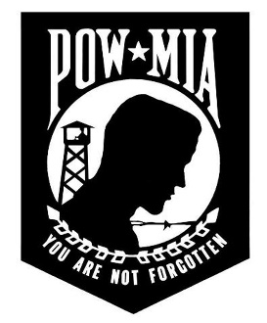
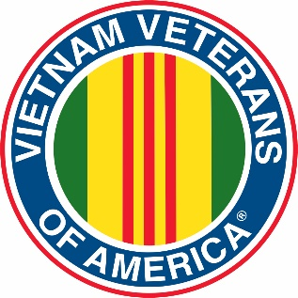
Vietnam Veterans of America
Chapter 331

June 13, 2020

The June 13, 2020 meeting was held at the VVA #331 Hooch – the meeting was called to order at 1:00 pm by President Jim Ottman with the Pledge of Allegiance and a moment of silence for our fallen and serving service members and POW/MIAs.

The treasurers report was given – the insurance was paid for the Helicopter Trailer

Membership reports 68 current VVA #331 members – the AVVA member count was not available

Scholarship reported that Abigail Curvello and Meredith Kameri were chosen as scholarship winners. Both winners and families were invited to China Beach. The committee will also do some re-wording of the scholarship application to include interviews with family members of a deceased Vietnam Veteran.

NEW BUSINESS:

Member Dave Schmitz’s wife passed away recently – a card was signed by present chapter members and sent to the family. Our heartfelt sympathy to the family

Dave Sharretts, who thinks he is the oldest rider, will be bicycling the High Ground fund raiser for the 30th time this year. This is a major fund raiser for the High Ground with over $52,000 raised last year. This is the 36th year for the ride. Member Jerry Simon has ridden this fund raiser for 35 of those years. A motion was made to sponsor Dave for $500 this year. The motion was passed

Mike Ptacek of Ptacek’s Grocery in Prescott holds an annual Chicken Feed and donates the proceeds to various organizations. This year half the profits, $448, was donated to VVA #331. A Thank You card was signed by present members.

Although we had voted NOT to have the Chili Feed breakfast this year the Gaslight approached us and asked if we would consider some type of food service as the normal grounds vendors will not be serving this year due to Covid 19 concerns. There was some interest in doing this fund raiser again in some form – either breakfast or an easy brat and chips type service. This was discussed and tabled until the July meeting.

A discussion was held regarding the Scholarship Program. The discussion regarded how to handle a situation where a scholarship recipient did not follow through with their schooling. It was determined that, should this happen, the third-place person would be offered the scholarship by the committee. This motion was voted on and passed.

Member Diane Carlson Evans has written a book about the raising of the Vietnam Veterans Women’s Memorial called “Healing Wounds” A Vietnam War Combat Nurse’s 10-Year Fight to Win a Women a Place of Honor in Washington, D.C. it is available on Amazon in Hardcover and Kindle formats.

UP COMING EVENTS:

China Beach is still schedule for August 8, 2020

ELECTIONS:

As there was a quorum, elections were held with the results being that we would continue with the current Officers (who’d have guessed!
President – Jim Ottman
Vice Pres – Jim Jennings
2nd Vice – Dave Roeker
Secretary – Dave Niederer
Treasurer – John Telschow
Chaplin – Bill Baker

NEXT MEETING:

The next meeting will be July 11, 2020 at the Hooch

Respectfully Submitted

David Niederer - Secretary

